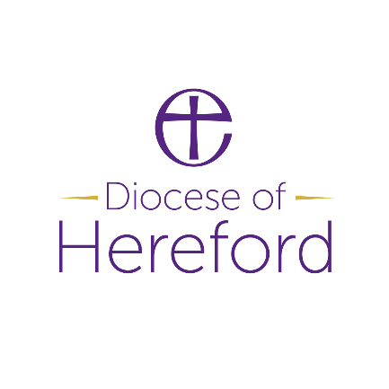

**Youth & Community Worker – Bishops Castle**

Dear Applicant,

Thank you for your interest in this role.

We are looking for a Youth & Community Worker with a heart for rural communities and walking alongside young people, to work under the leadership of our Youth Pioneer as part of our Bishops Castle Youth Hub. You will be able to creatively develop a local youth & community ministry programme, supporting the mental health and wellbeing of young people, developing relationships with local schools and community groups, and contributing to developing church with and for young people in Bishops Castle and the surrounding areas. Through youth and families work and growing an informal community of young people where faith can be shared, you will enable young people, often for the first time, to begin to explore their own spirituality and faith journeys.

This is an exciting time for our diocese as you will be enabling young people, often without any other connection to church, to connect with God and explore faith as part of a growing network of Youth Hubs across South Shropshire and Herefordshire. If you are passionate about community outreach, rural schools ministry, sharing the Good News of Jesus through action and words and joining in with what God is doing through our local churches and communities in this beautiful part of the world, we would love to hear from you!

St. John’s Bishop’s Castle is an Inclusive Church committed to welcoming all and we are committed to supporting this new and emerging ministry in our community. The role will be focussed on relational youth work, schools and school transition ministry, families ministry and rural evangelism. You will be someone who is sensitive to local context, able to sensitively work alongside local community leaders and groups, and with a deep understanding of supporting mental health and wellbeing in young people. We are excited about how God has been at work in our communities and we are ready to support and work alongside you as you join us and we follow Jesus together!

Do you feel called to be part of this journey? If you would like to speak further about this and Youth Hub roles in Hereford Diocese, please get in touch.

Rev. Stephanie Fountain – Priest in Charge, St. John’s Bishop’s Castle: 01588 630324 [stephaniefountain@yahoo.co.uk](mailto:stephaniefountain@yahoo.co.uk)

Lizzie Hackney – Lead Intergenerational Missioner and Youth Hub Lead: 07833 117565 [e.hackney@hereford.anglican.org](mailto:e.hackney@hereford.anglican.org)

Church Website: <https://ridgewaychurch.wordpress.com/>    
Hereford Diocese Website: <https://www.hereford.anglican.org/>